Lab 4:

Introduction:
In this lab you will learn how to track and evaluate large language model (LLM) prompts in watsonx.governance. We will complete the following tasks:

- Create a use case
- Test and evaluate a prompt
- Promote the prompt to production
- Use the prompt from a client application.

Required software, access, and files
- You will also need to download sample prompts and code samples from this folder.
- Access to the lab files and contents in the workshop repository.

AI Governance and watsonx.governance
AI Governance is a discipline that includes business process and implementation of best practices for creating, deploying, managing, and monitoring AI artifacts, such as Machine Learning (ML) models and Large Language Models (LLMs).

In the past, components of AI Governance were implemented by companies in highly regulated industries or for specific use cases. For example, companies in the financial industry must have Model Risk Governance (MRG) practice to comply with regulatory requirements that were first published in 2012, and even as early as 2000. However, in some cases the implementation of AI Governance was simply keeping track of models in a spreadsheet or a document.

During the past few years various government organization proposed and approved laws for governing AI. Here’s an example of a law related to the use of AI:
Source

Regulatory landscape for AI continues to evolve, with important regulations such as the United States AI Bill of Rights and EU AI Act will likely accelerate development of guidelines and laws.
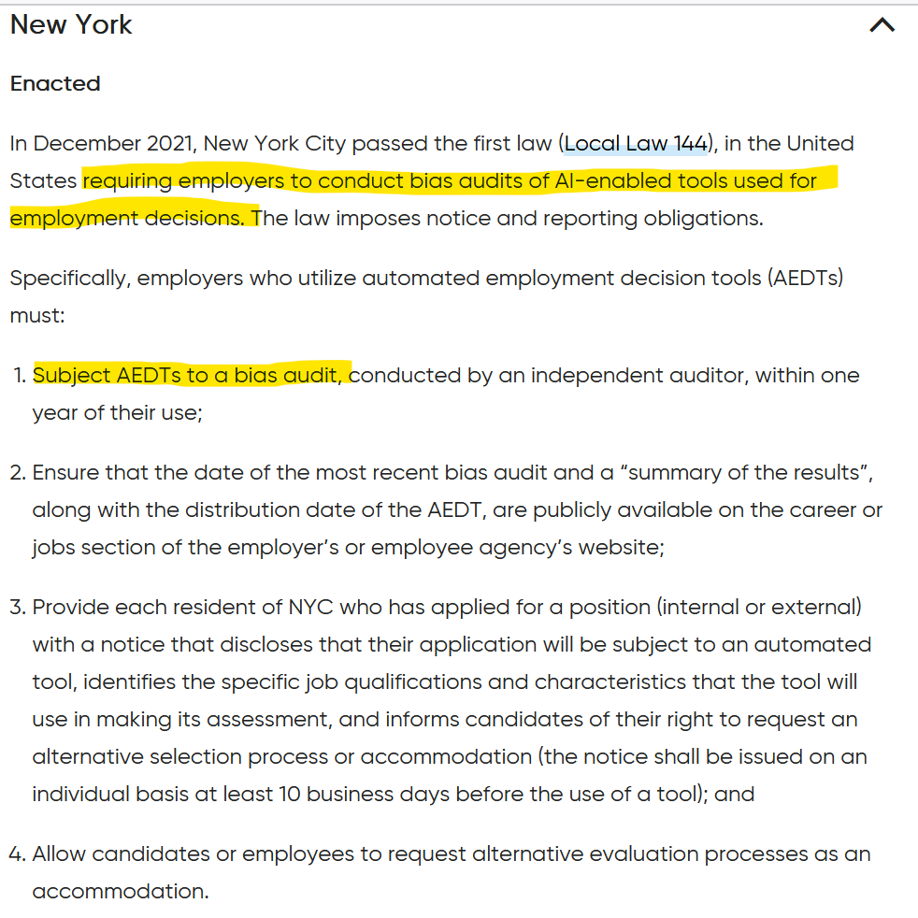
One of the best ways to prepare for upcoming regulations is to infuse AI Governance in several steps of the ML model and LLM lifecycle. Watsonx includes multiple features that will streamline not only governance of models, but also improve operationalization and simplify maintenance.

In this lab we will focus on operational aspects of implementing AI Governance.

Watsonx.governance
Many software offerings today are packaged as individual services that include a set of features. Services provide granular capabilities that can be included in multiple offerings. IBM’s watsonx.governance includes two services:

- AI Factsheets: used to capture model and prompt metadata as well as track model lifecycle

- OpenScale: used to monitor model performance, accuracy, provide explainability, and alert for bias.

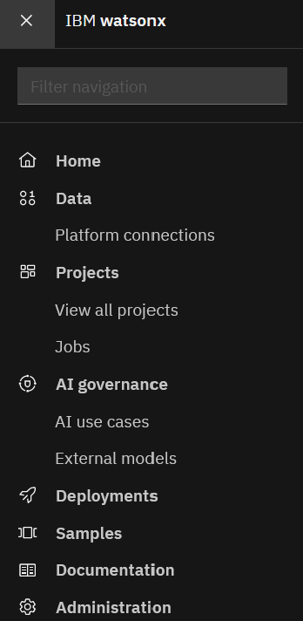
It’s common in microservice software design to have prerequisite services. In case of watsonx.governance, the prerequisite services are watsonx.ai and Watson Machine Learning.

From the end-user perspective, all services are seamlessly integrated into watsonx UI. As additional services are provisioned, new actions (menus/buttons) become available in various components of watsonx. In other words, end users don’t need to know the names of the services, but this information may be useful to administrators. For example, if a user doesn’t see a certain action, the administrator can check if the required service was provisioned.

Part 1: Create an AI Use Case
Creating a Model Inventory is the first step in better organization of AI artifacts.

1. Login to watsonx in your browser.
2. From the main menu in the top left corner select AI Use Cases

Note: If you don’t see this menu, check that OpenScale service was provisioned in your IBM Cloud account.



Navigate to the AI Use case menu again and click the New AI Usecase button.

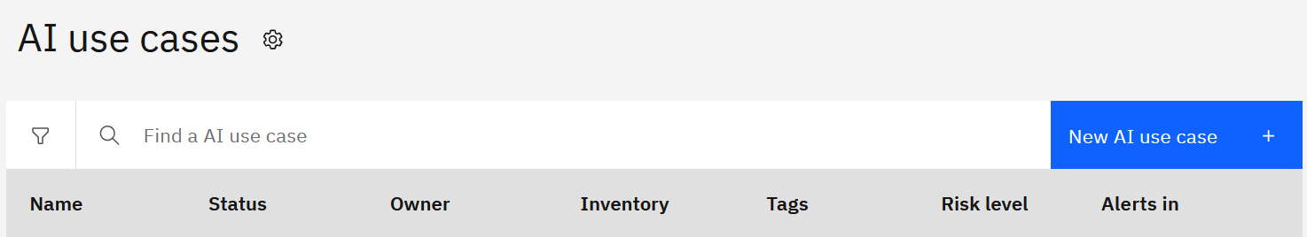

Review metadata options available on this screen.

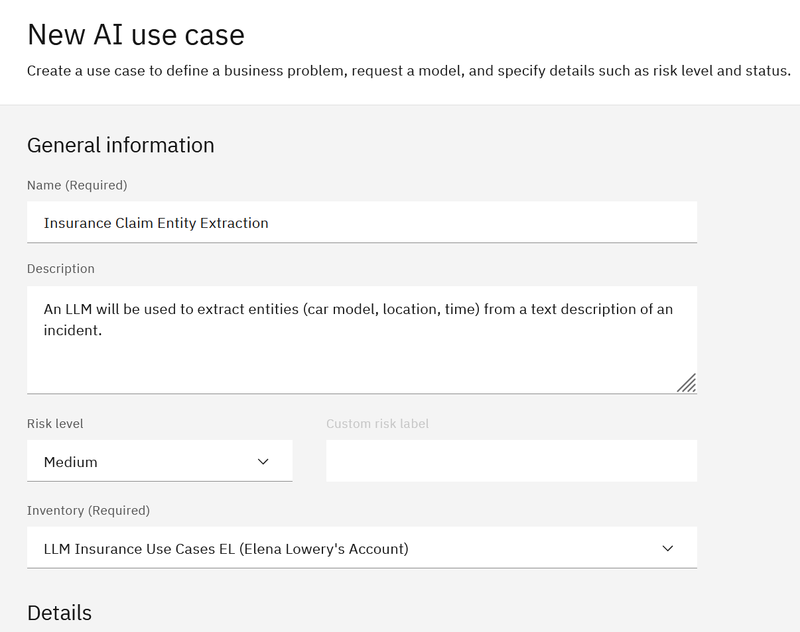
First, we provide use case information, such as name and description, as well as risk level and inventory name. Risk level designation can be based on industry regulations or an organization’s evaluation of risk. It can also help with prioritization of work if multiple models perform below specified thresholds.

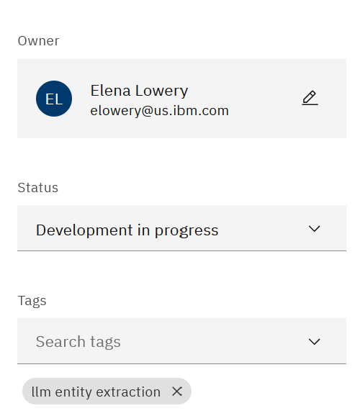
On the right side, we can capture some aspects of model lifecycle process, specifically the status, which we decided to set to Development in Progress. Adding tags to the use case entry will help us easily find use cases in the inventory.
Create a use case record using the sample values in the screenshot or provide your own. The detailed Use Case view provides the summary of details we entered.

The detailed Use Case view provides the summary of details we entered.
If you click on the Lifecycle tab, you will notice that we don’t have any information yet because we have not added project assets that we want to track.
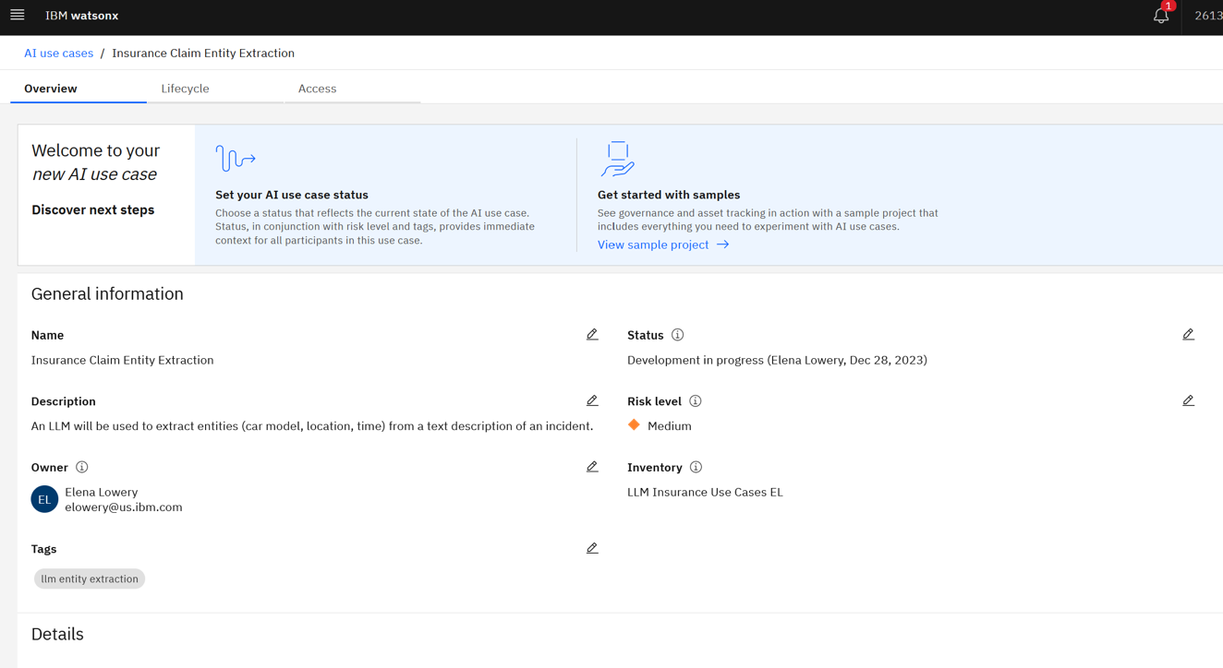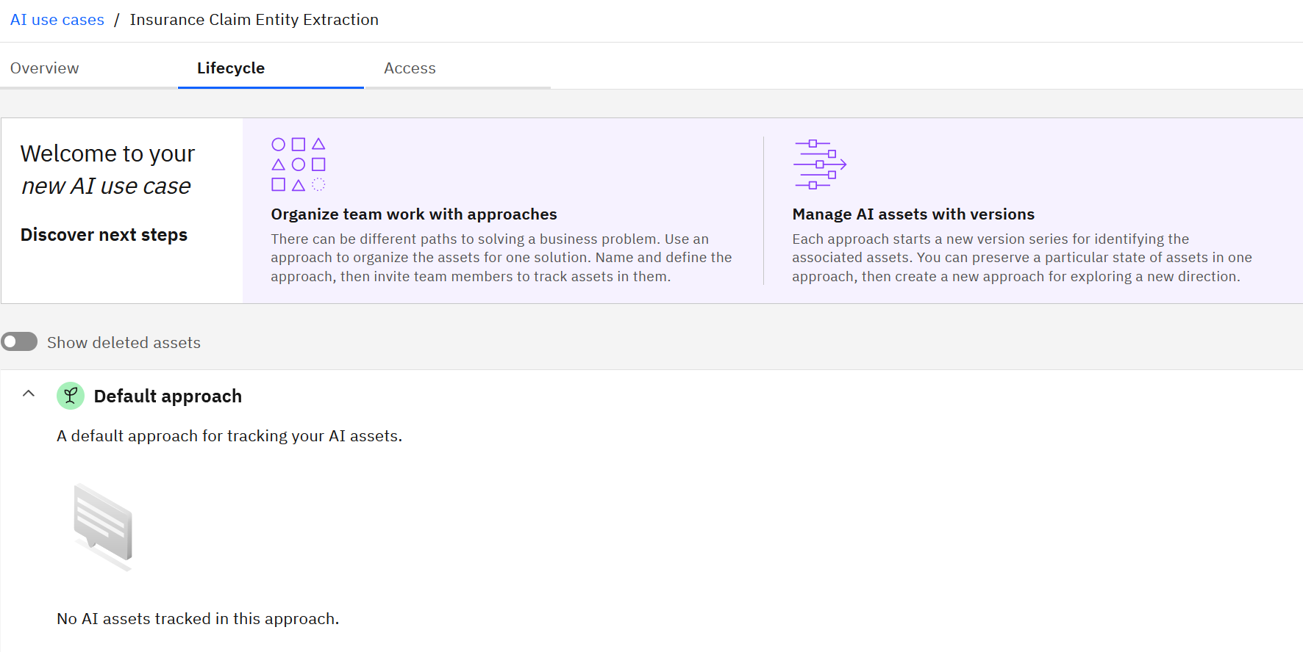

Create a second use case entry for the Summarization use case. You can use the values in the following screenshot or provide your own.
When finished, you AI use case view should look similar to this screenshot.
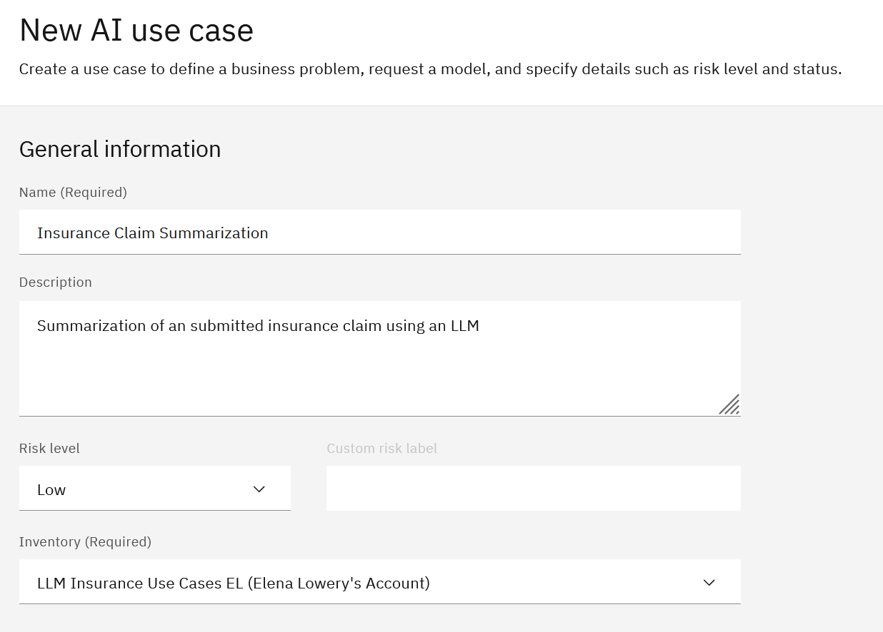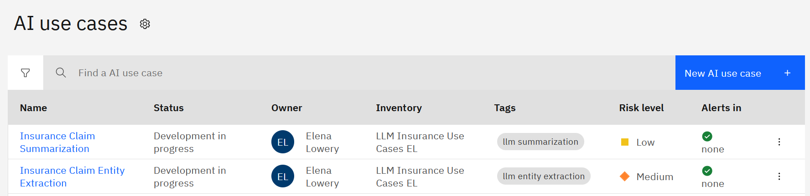

We have completed setting up a Model Inventory and creating metadata for AI use cases that we will implement with LLMs. In just a few minutes, we provided a better organization for auditing, tracking, and monitoring AI assets that will be used in various applications.
Part 2: Prompt Development and Evaluation
In this section we will use provided prompts for the defined use cases to walk through the lifecycle of deploying a prompt/LLM for use by production applications. We will not cover the iterative process of prompt engineering and prompt tuning. Since we’re focusing on governance, we are making the assumption that the development process for the prompts has been completed.
First, we will import the project that contains prompts into watsonx.

In watsonx navigate to the Projects view (from the main menu in the top left corner)
and click the New Project button.

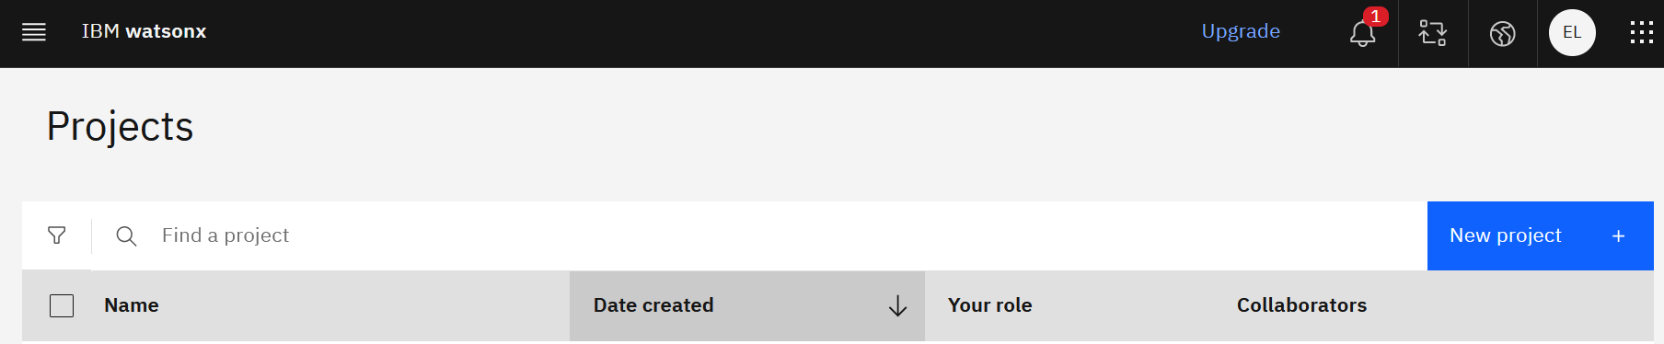

Click the From file option and navigate to your copy of the Insurance_LLM_Use_Cases.zip.

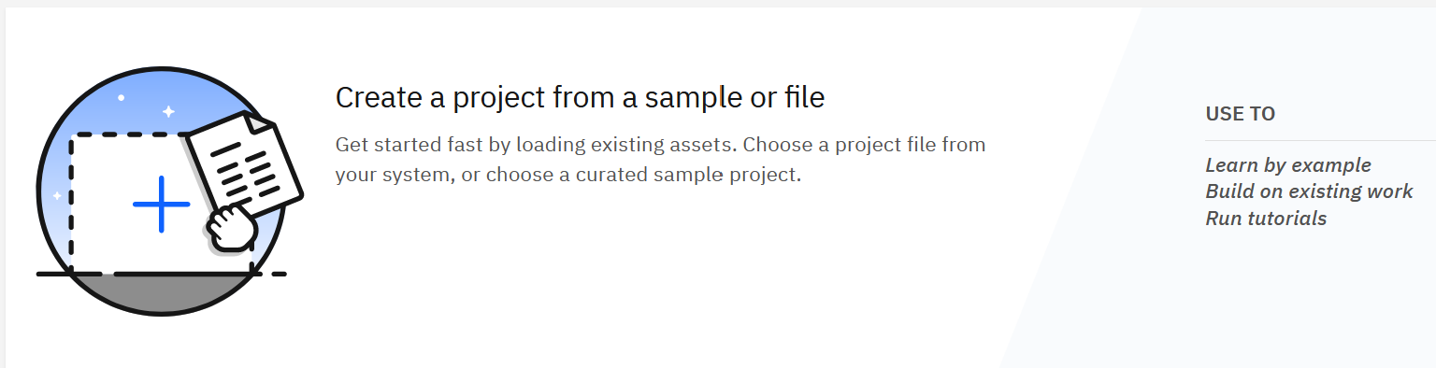

Provide a unique project name and click Create. 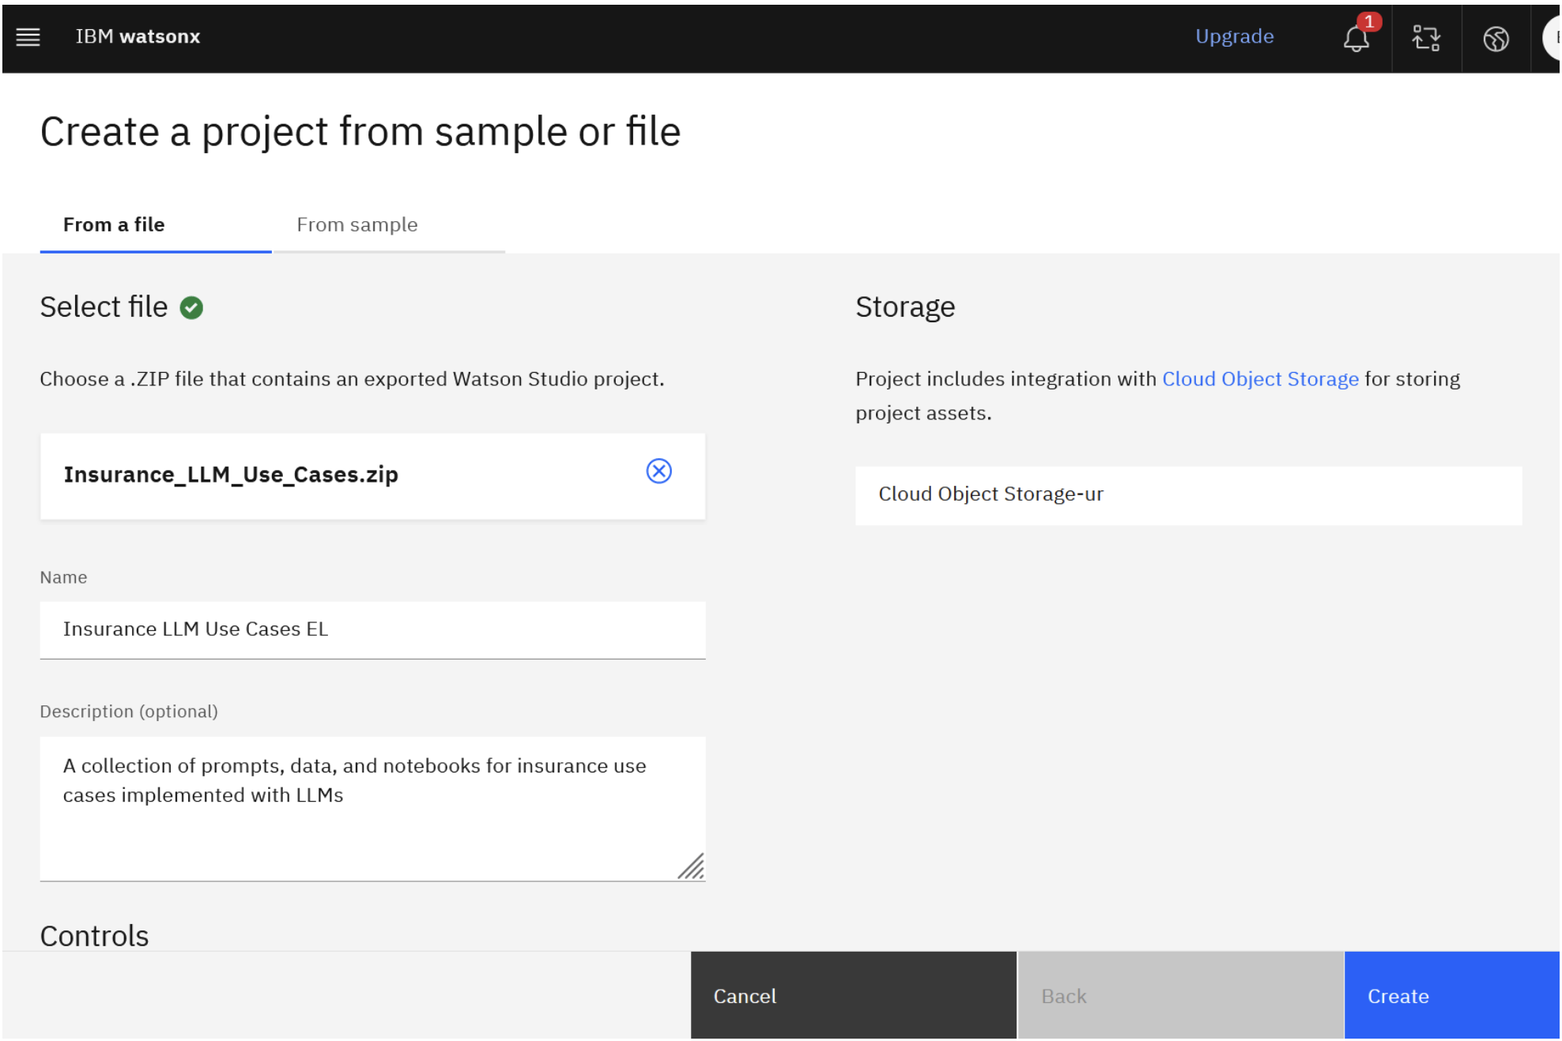
Switch to the Manage tab, then select Services and Integrations tab. Click Associate Service.
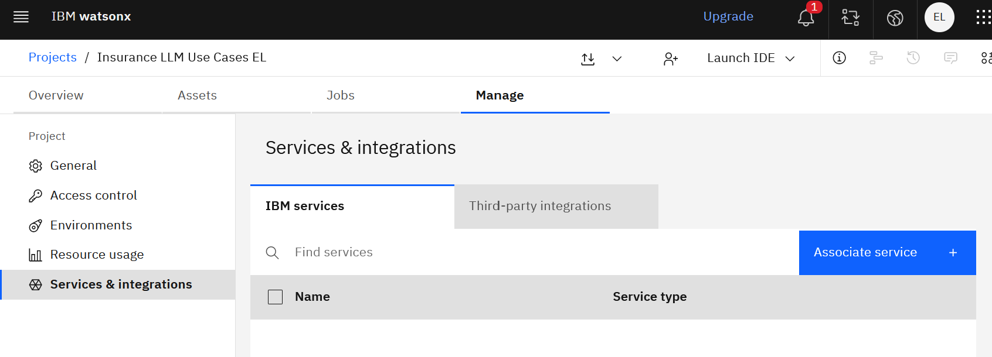
Select the displayed Machine Learning service and click Associate.
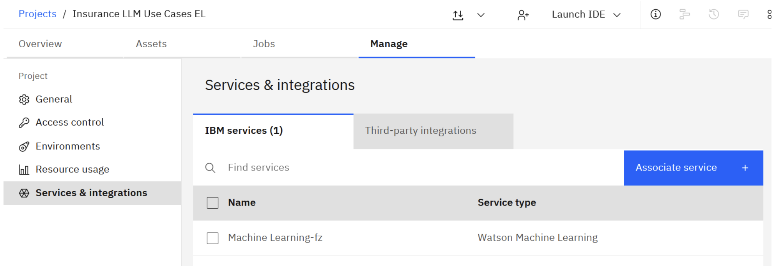

Switch to the Assets tab and expand Prompts.
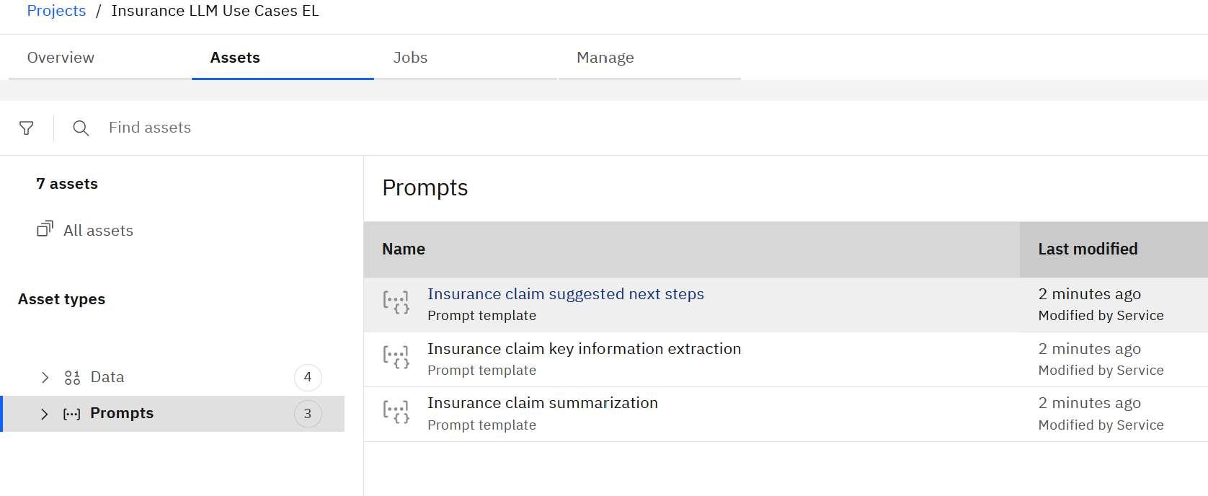
Let’s review prompts for our AI use cases.

Click on the Insurance claim key information extraction prompt.We are making an assumption that you’re familiar with prompt structure, but let’s point out a few things that may be unique to prompt format in the Prompt Lab.

Note: when prompted, check all the boxes to agree to terms and click skip tour.

When you open the prompt, you can choose to open in preview mode or edit mode. Edit mode will lock the prompt and allow you to make changes.

Choose Edit for now.

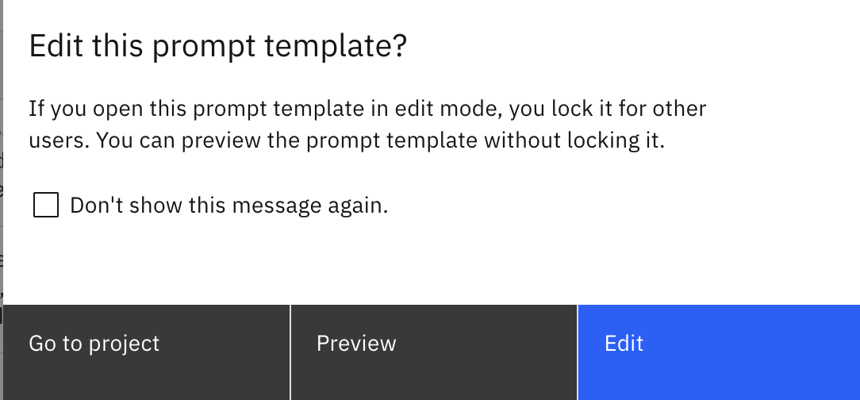

The prompt is displayed in either Structured or Freeform view. Switch to the Freeform view.
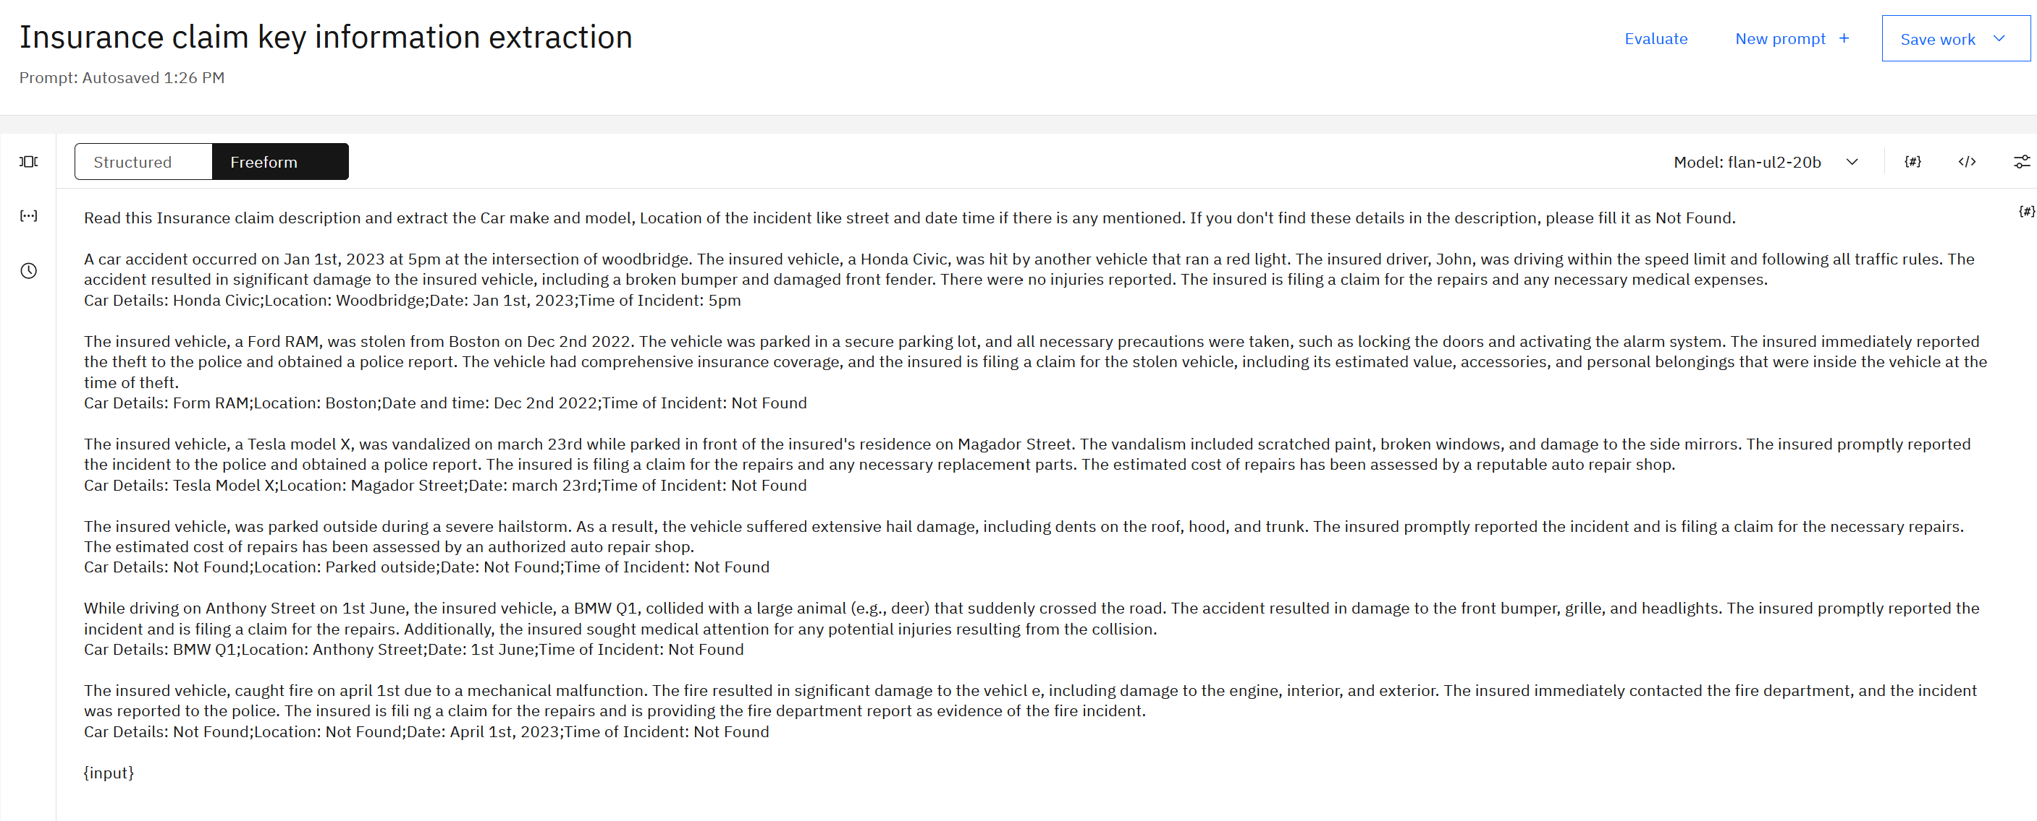
In the beginning of the prompt we see the instruction for the LLM: Read this Insurance claim description and extract the Car make and model, Location of the incident like street and date time if there is any mentioned. If you don't find these details in the description, please fill it as Not Found.

After that we have a few examples with text and extracted entities, which means that this is a few-shot prompt.


At the end of the prompt we have an {input} variable. This variable will be passed in during inference – it will contain the text (claim summary) from which the LLM will extract entities.

In the top right corner of the Prompt Lab we see that this prompt was created for the flan-ul2-20b model.
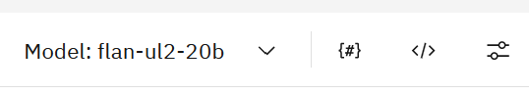
`Next to the model we have the parameters button, where we can review and add parameters for the prompt. Notice that our parameter name is input (referenced in the prompt as {input})

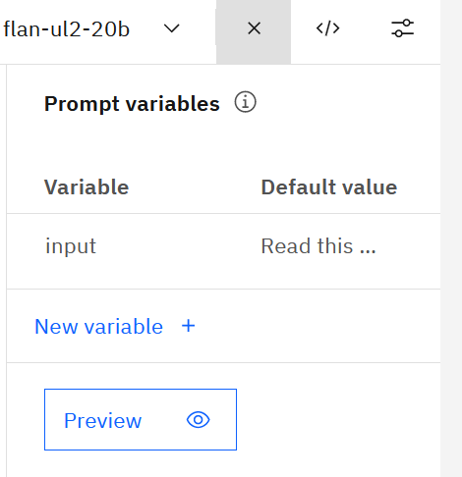

Finally, we can view model parameters by clicking on the Parameters icon.

If you wish, test the prompt by clicking the Generate button. We get the results because the {input} variable has a default value (claim text).
Return to the project view by clicking on the project name on the top of the screen.
Expand Prompts on the Assets tab. Click on the vertical ellipses menu and select View AI factsheet.
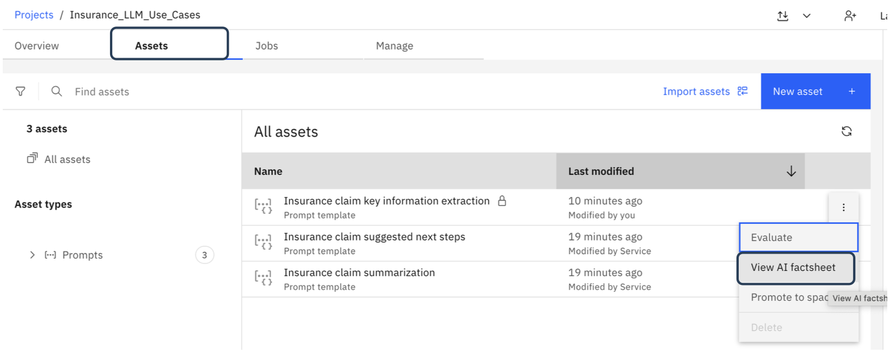
Notice that the factsheet captures the details (prompt, model parameters) that you have used in the Prompt Lab. At this time, if you make a change in the prompt template using the Prompt Lab, it will be automatically reflected in the factsheet.

If you wish, in the Prompt Lab change the max number of tokens model parameter and verify that the changes are reflected in the factsheet.

Notice the comment on top of the factsheet: we can make changes to the prompt template until we start tracking it.
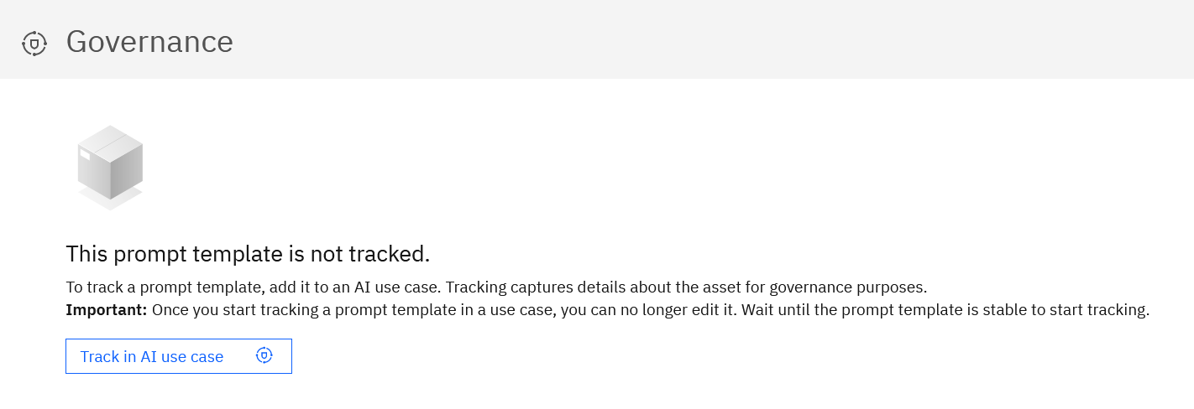
Since we made the assumption that our template is final, let’s start tracking.

Click the Track in AI use case button and select the entity extraction use case you created earlier.

Click Next on Define Approach screen, then select Stable on the Assign model version screen.

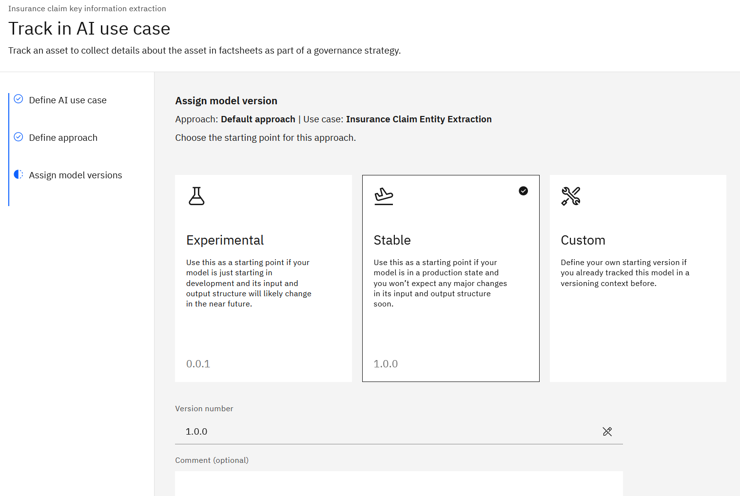
Click Next.

Note: we will review approaches later in the lab.

Click the Track asset button to finish this task.

Typically, a data scientist will perform testing prior to releasing the template for production. The evaluation process that we will complete in the next few steps is performed primarily for the purpose of documenting test results.
Evaluation metrics provided in watsonx are standard evaluation metrics that are used for various LLM tasks such as classification, summarization, and extractions. You can learn more about evaluation metrics in documentation.
Evaluation of LLMs requires “reference data”, which is the “expected output” for the LLM. Reference data can be created manually or generated using various approaches. For generation use cases such as summarization and content generation, it’s important to provide high quality reference data, which means that it may need to be created by experts.
Example of reference data for information extraction use case:
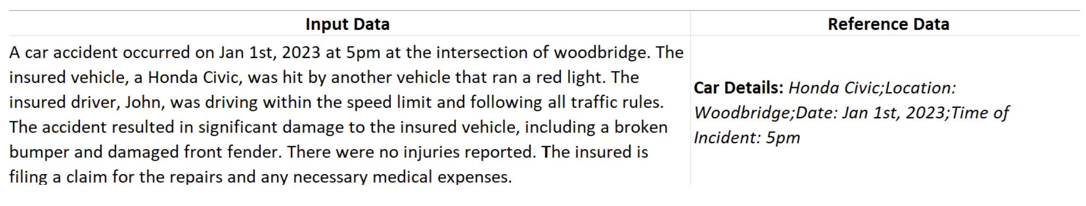
Click Evaluate in the factsheet, then Evaluate on the Run an evaluation job screen. 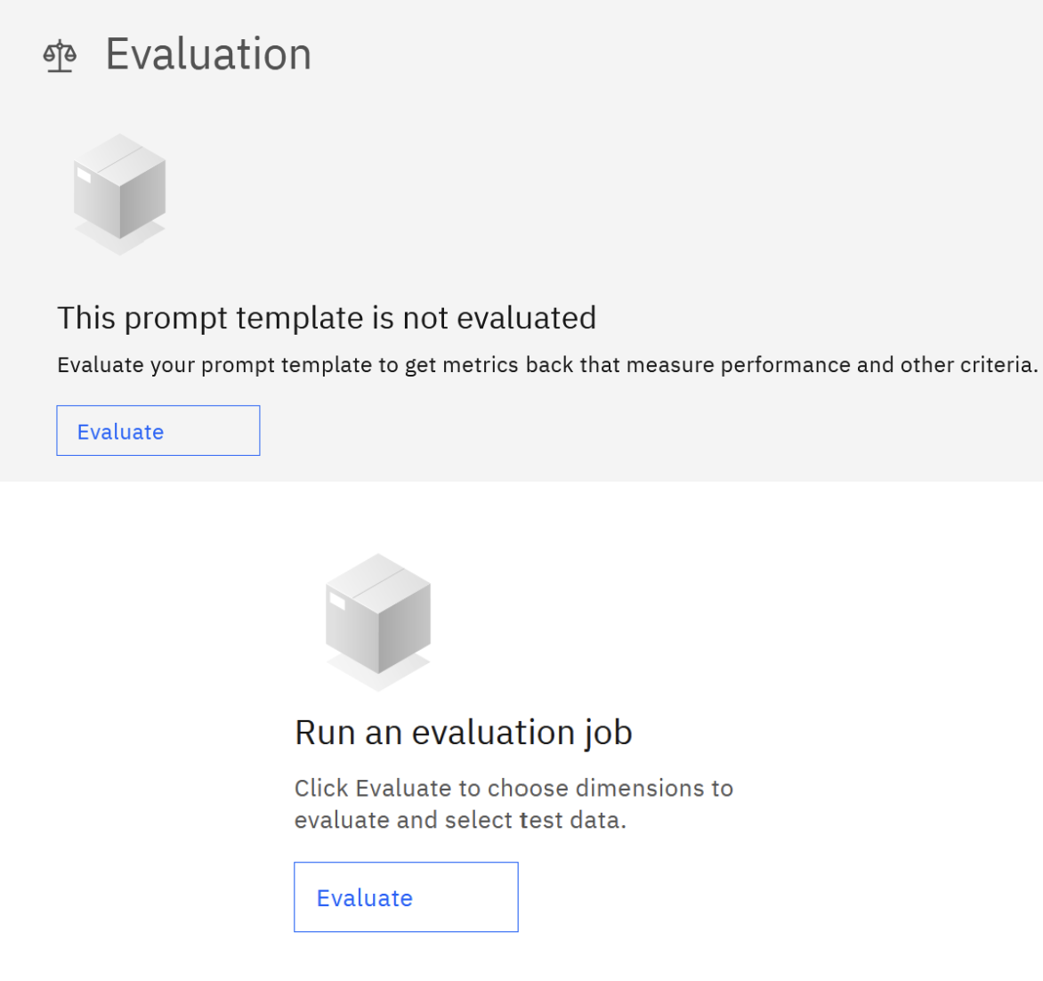
Notice that evaluation metrics relevant to our use case, extraction, were automatically selected.
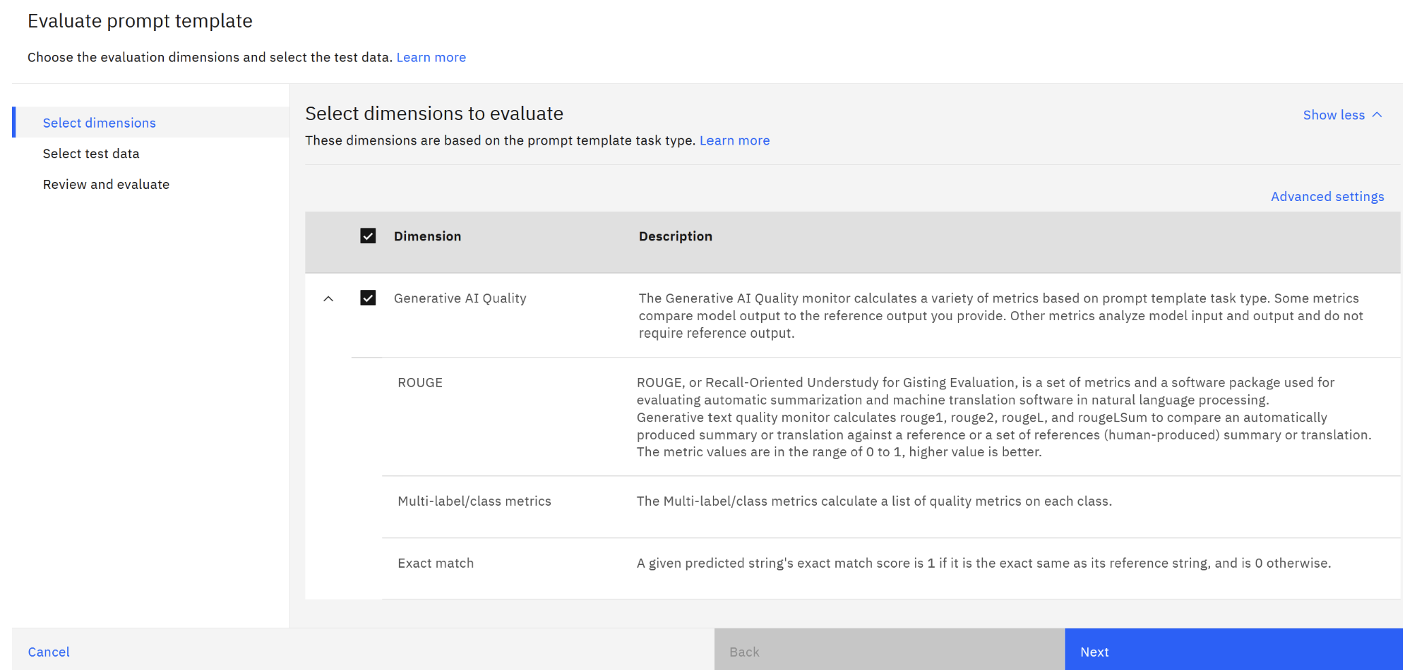

As a reminder, the task type is captured in the factsheet.
Note: The task type is specified when we save a prompt. Since we imported a prompt, we did not need to complete this step.
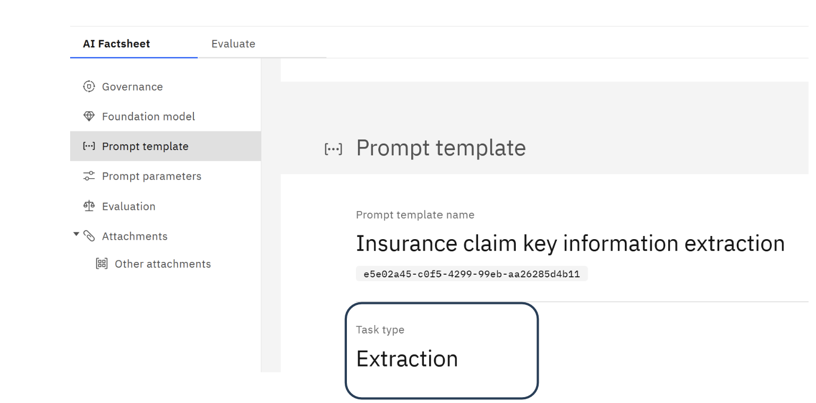
Click Next on the Evaluate Prompt Template screen.
On the select data screen, navigate to the text_extraction_claims.csv file from the workshop data.

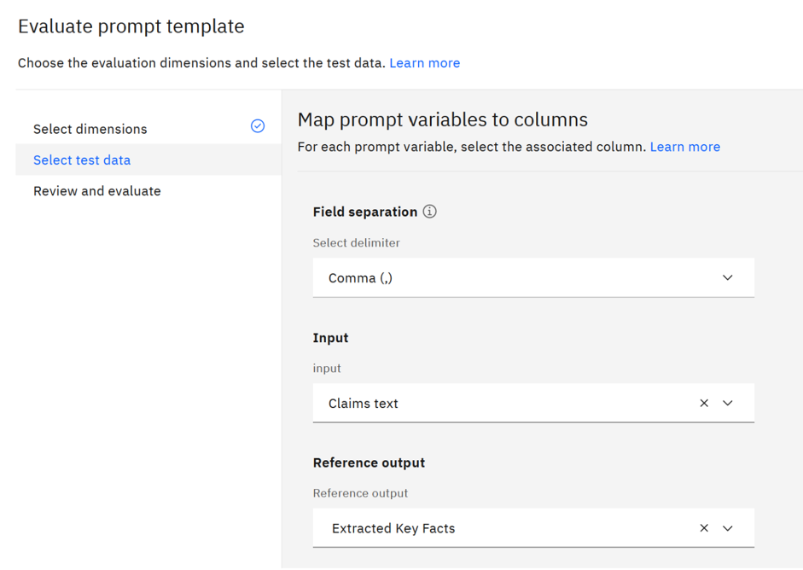
If you wish, open this file to review its content. As we discussed earlier, this file provides “expected LLM output” for the instruction that we’re asking it to perform.
Select Claims text and the input and Extracted Key Facts as reference output.
Click Next.

Click Evaluate to run evaluation.
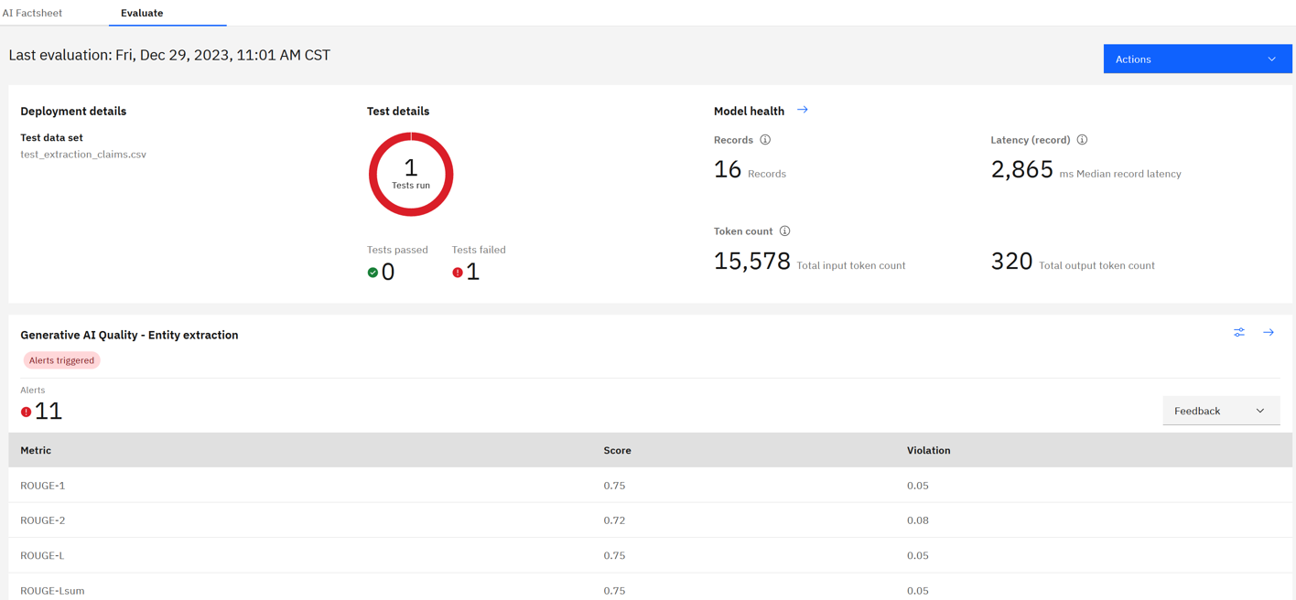

Notice that the test result is failed. We also have 11 alerts, which means that the calculated evaluation metrics are below specified thresholds.
To view the thresholds, click on the Configuration icon.
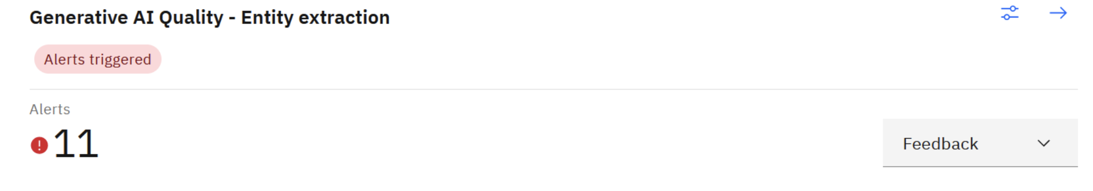
Compare the rouge metric thresholds defined on this screen with the values from our test run.
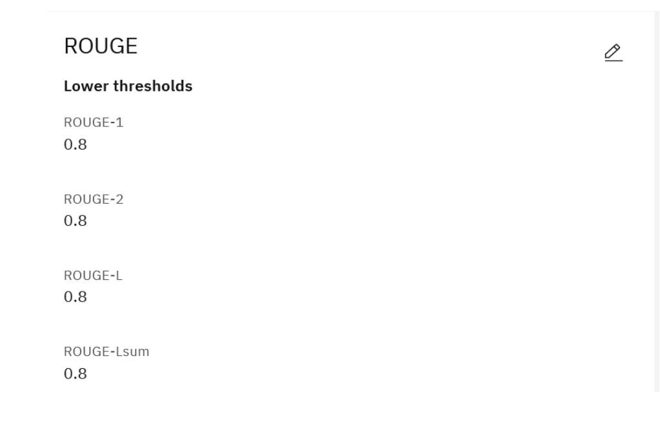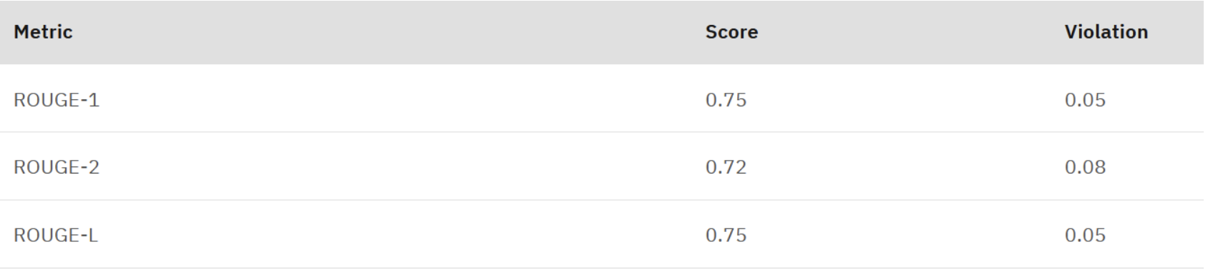
Notice that the “violation” is the difference between the threshold value and the test result value.
Next, we will create another prompt template to understand prompt format that’s required for watsonx.governance implementation.
Locate the sample prompt Extract_info_insurance_claim_llama Prompts folder in the workshop data.
Navigate to your project and create a new prompt. In the Prompt Lab use the Freeform view to past the sample prompt. Make sure to select the llama-2-70b-chat model and set max tokens to 200. 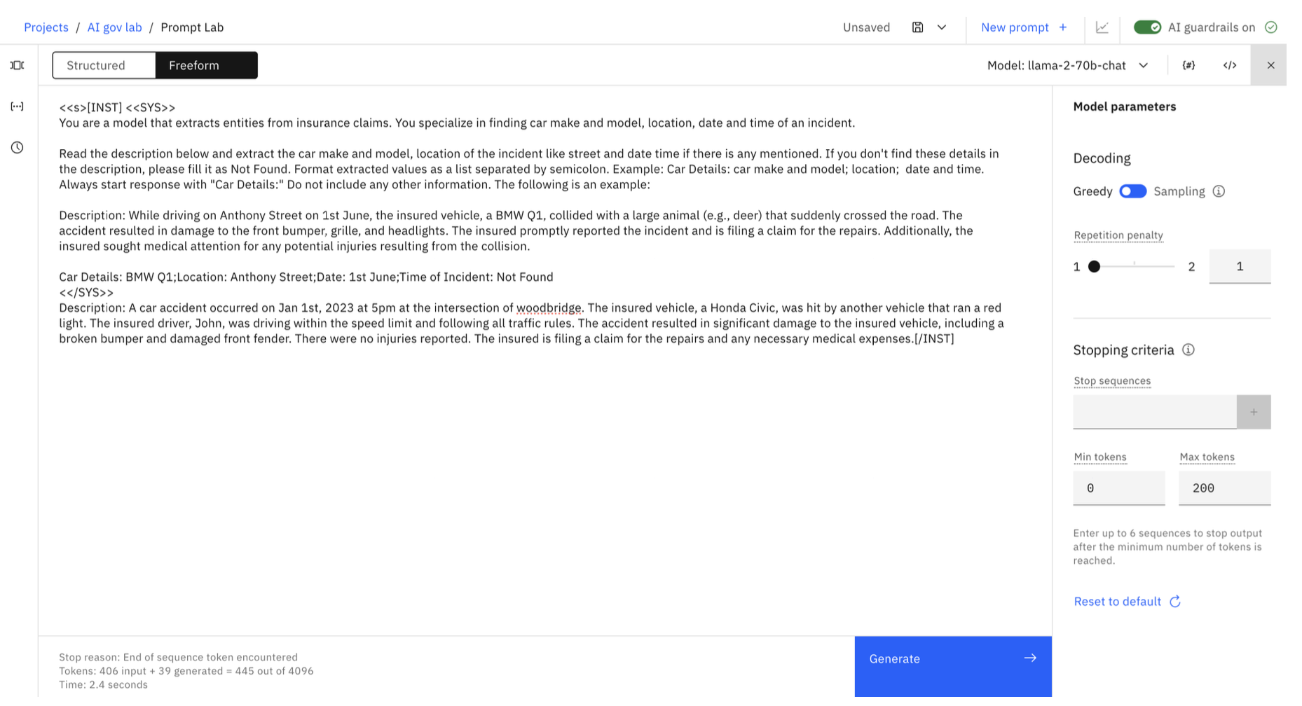
Notice that this prompt has been formatted specifically for llama (with INST and SYS tags). It’s also a one-shot prompt, which, compared to the first example, will utilize less tokens for inference.
Click the Generate button to test the prompt.
Notice that the Evaluate button (or icon) is disabled for this prompt. In order to evaluate, track, and deploy this prompt, we need to add a parameter – the input that will be passed to the prompt.
Note: You will also not be able to track or deploy prompts without parameters.

In the Prompt variables view of the Prompt Lab, add the claim_desc parameter.
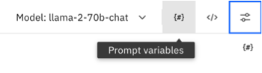
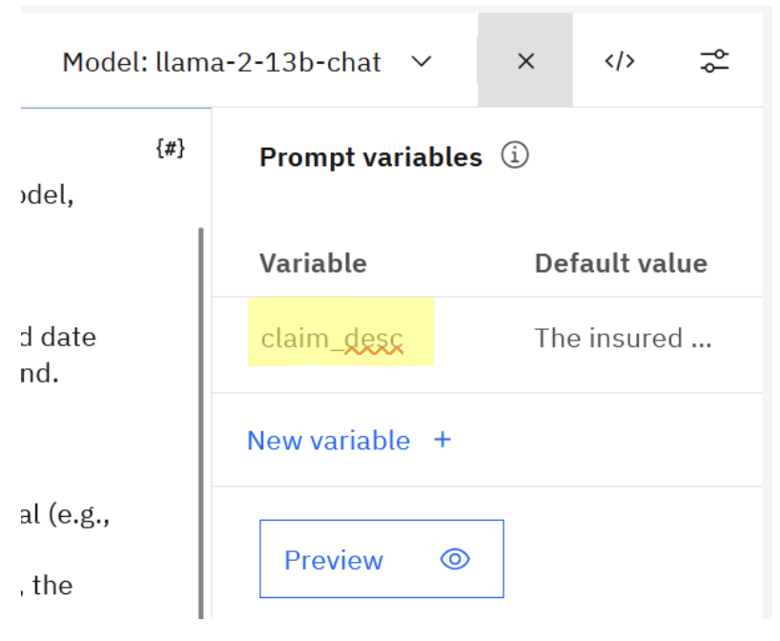
You can use the following value as the default value:
A car accident occurred on Jan 31st, 2023 at 5pm at the intersection of woodbridge. The insured vehicle, a Tesla Model Y, was hit by another vehicle that ran a red light. The insured driver, John, was driving within the speed limit and following all traffic rules. The accident resulted in significant damage to the insured vehicle, including a broken bumper and damaged front fender. There were no injuries reported. The insured is filing a claim for the repairs and any necessary medical expenses.
If you wish, you can provide a different claim description from the test file we used earlier. Next, add the parameter enclosed in curly brackets to the prompt.
Notice that now the Evaluate button is enabled.
Save the prompt template by clicking the save icon then save as. Make sure to select Extraction as the task type.
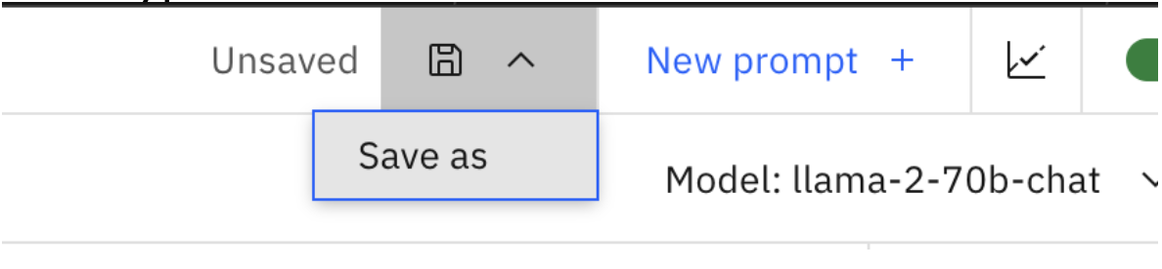
Important Note: At this time the task type will automatically determine which evaluation tests will be run. You will not be able to change the task type after saving the template.
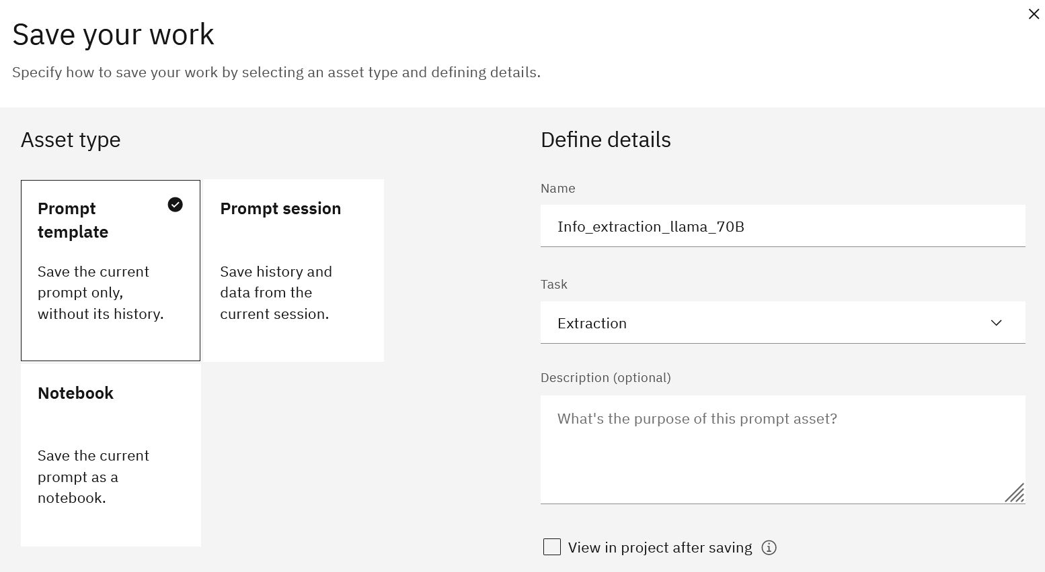
Click the evaluate icon to run evaluation for this prompt. Notice that the rouge score for this prompt is higher, it does not breach the configured threshold.

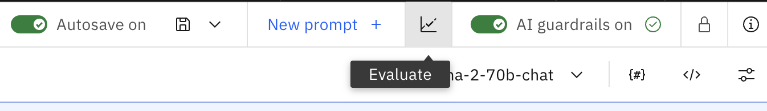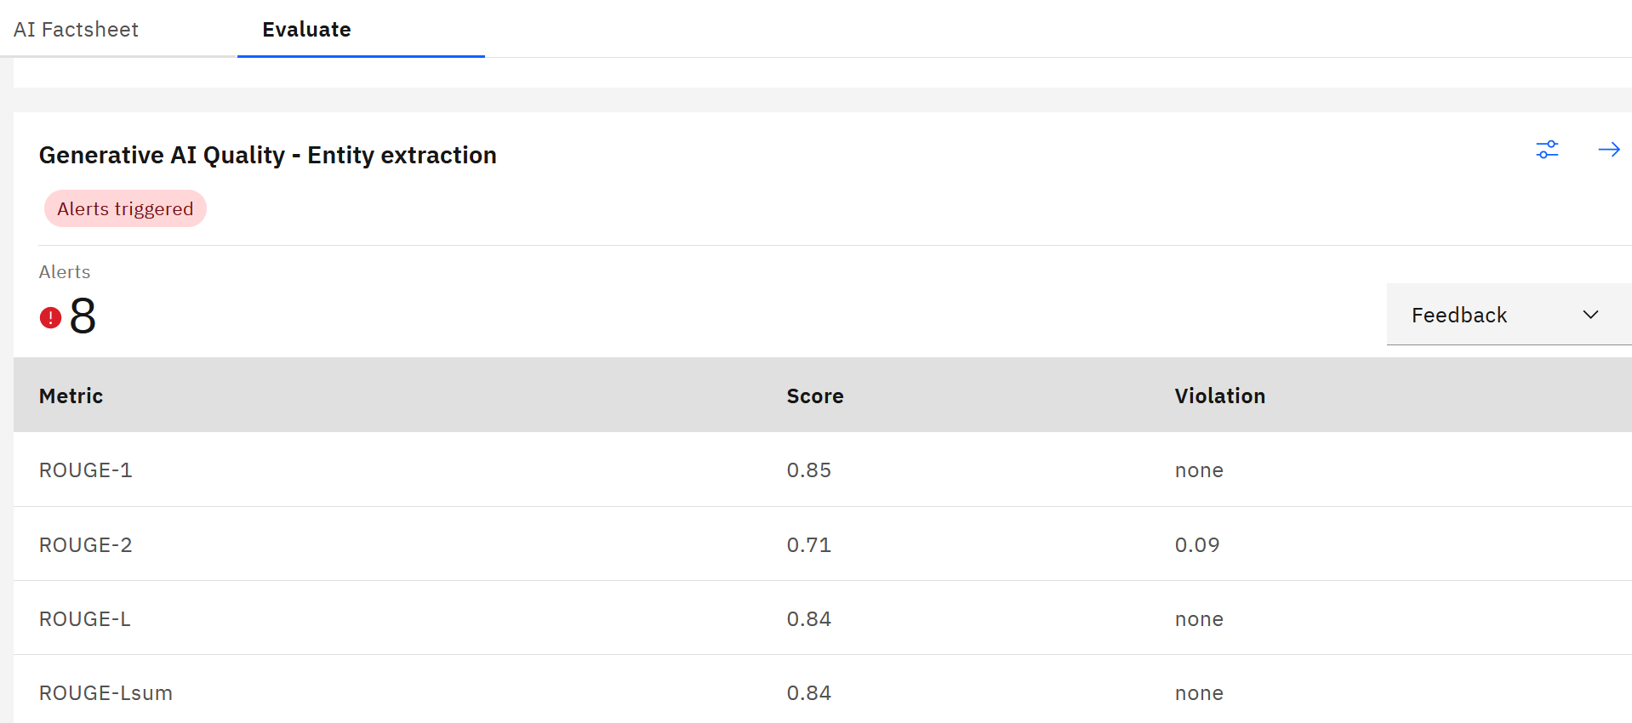
Next, we will enable tracking for this template following the same steps as you’ve done for the other prompt.
Before we do that, we will create a new approach for our use case. Approaches help us organize different implementations for the same use case. For example, some companies may do A/B testing to find out which prompt/model deliver the best performance.
Navigate to the AI use cases view and select your use case.
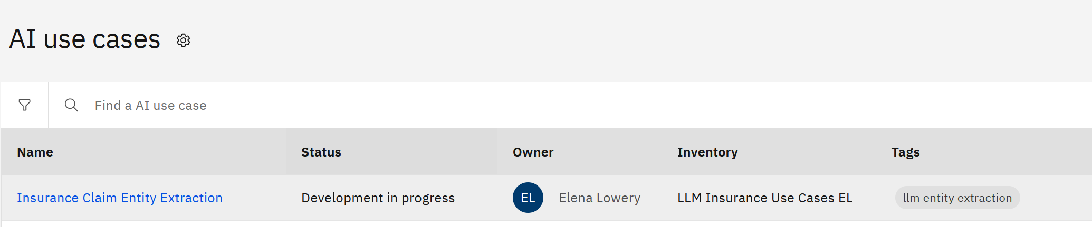

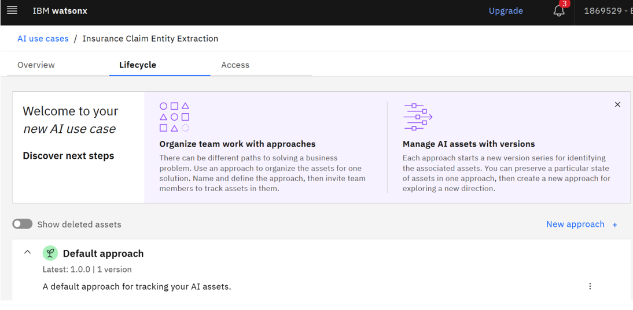
In the Lifecycle view click New Approach.

Create the new approach using values similar to the ones shown in the screenshot and click Create.
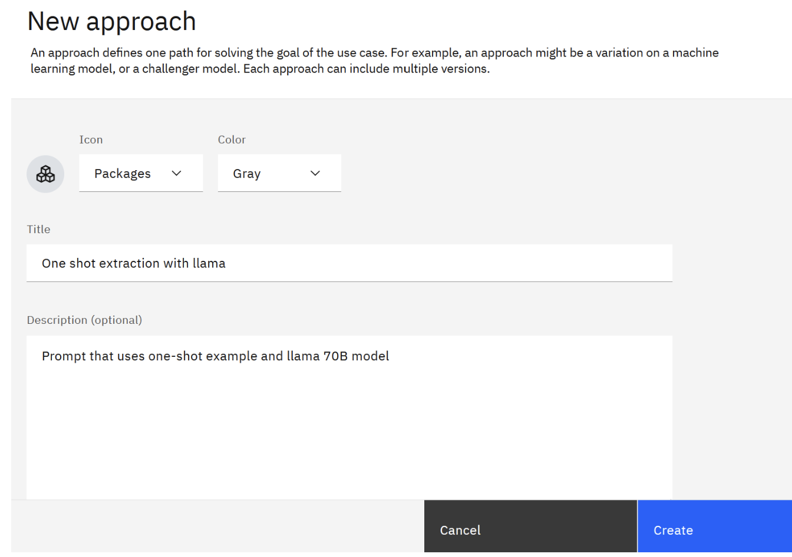
At this time we do not have any assets tracked for this approach.

Navigate to the Factsheet view of your llama prompt (from the project Assets view).
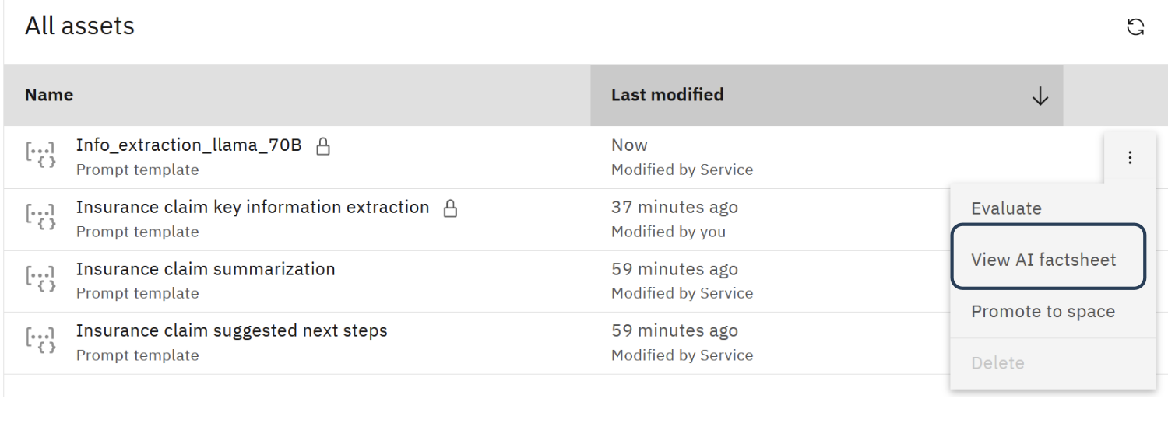
Click Track in AI use case. Select your use case and the newly created approach.
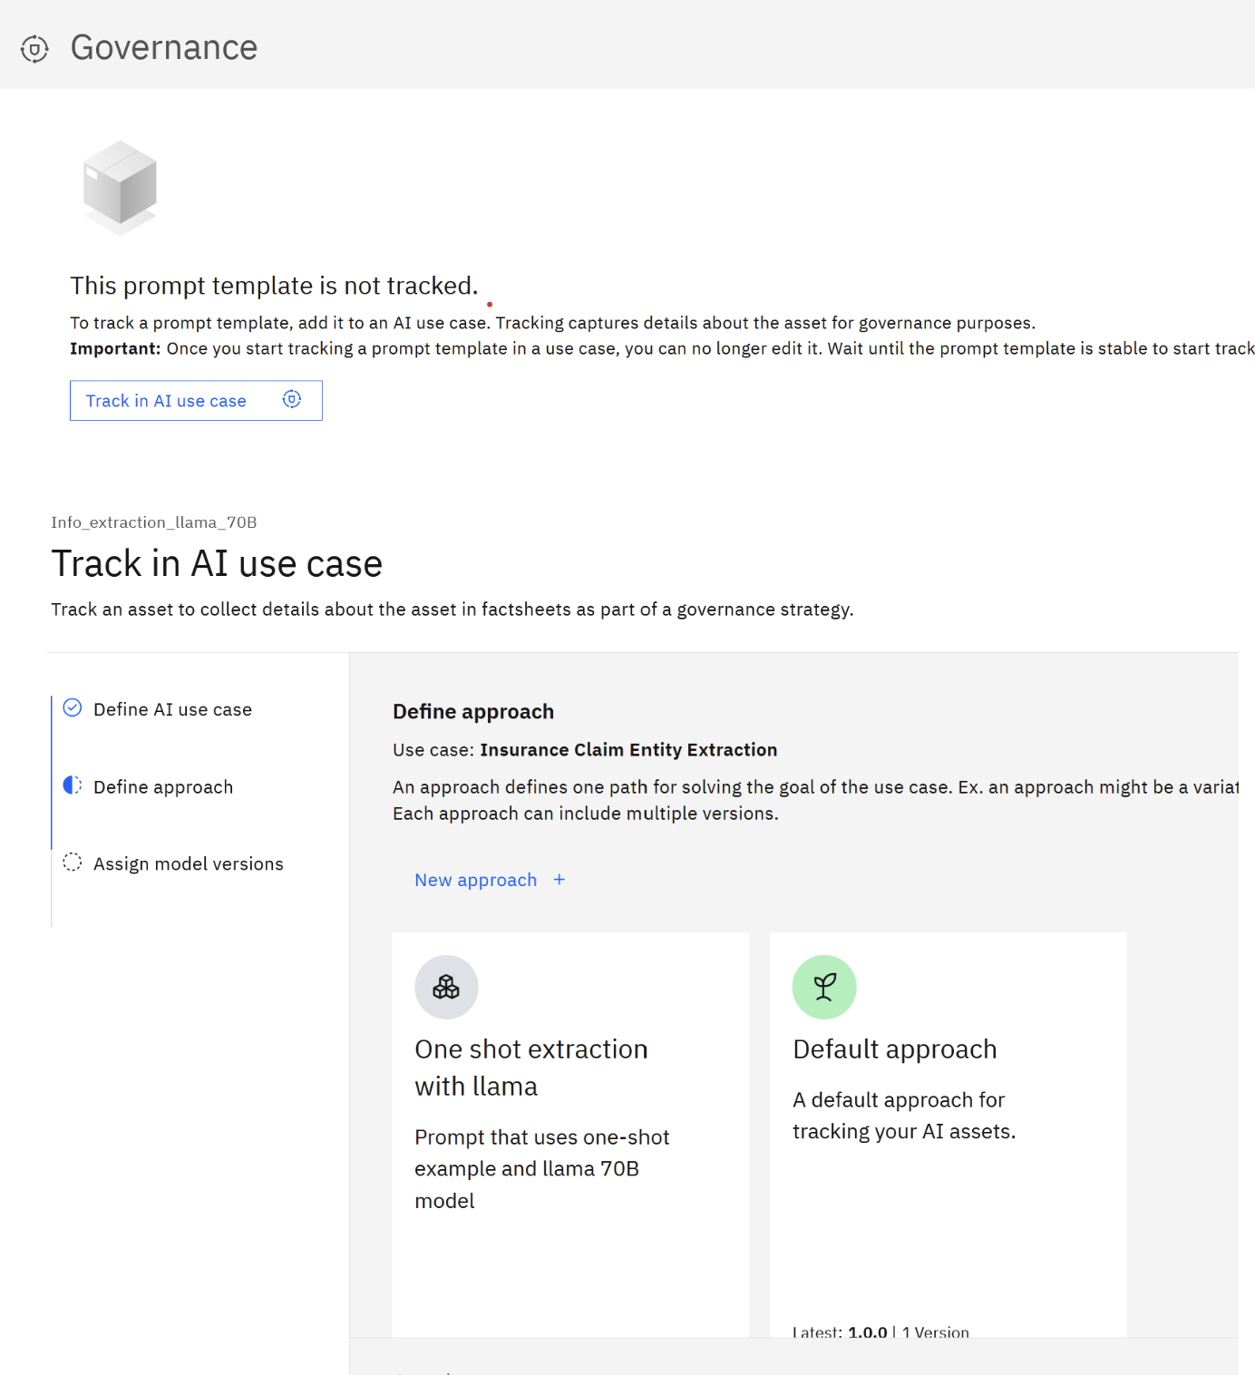
Select the Stable model version, click Next, then click Track asset.
If you wish, come back to the AI use case view and verify that both templates are now tracked – one under the Default approach, and one under the custom one that we created.
Next, we will promote both prompt templates to production. In this lab we will skip the validation step. Validation is similar to model evaluation that we have done in this lab, but it’s usually done by a different team in a different watsonx project. If you would like to learn more about the validation step, you can review documentation.
24. From the main menu navigate to Deployments and create a new deployment space using values similar to the following screenshot.
Notes:
• Make your deployment space name unique by adding your initials. • Your machine learning service name will be different.
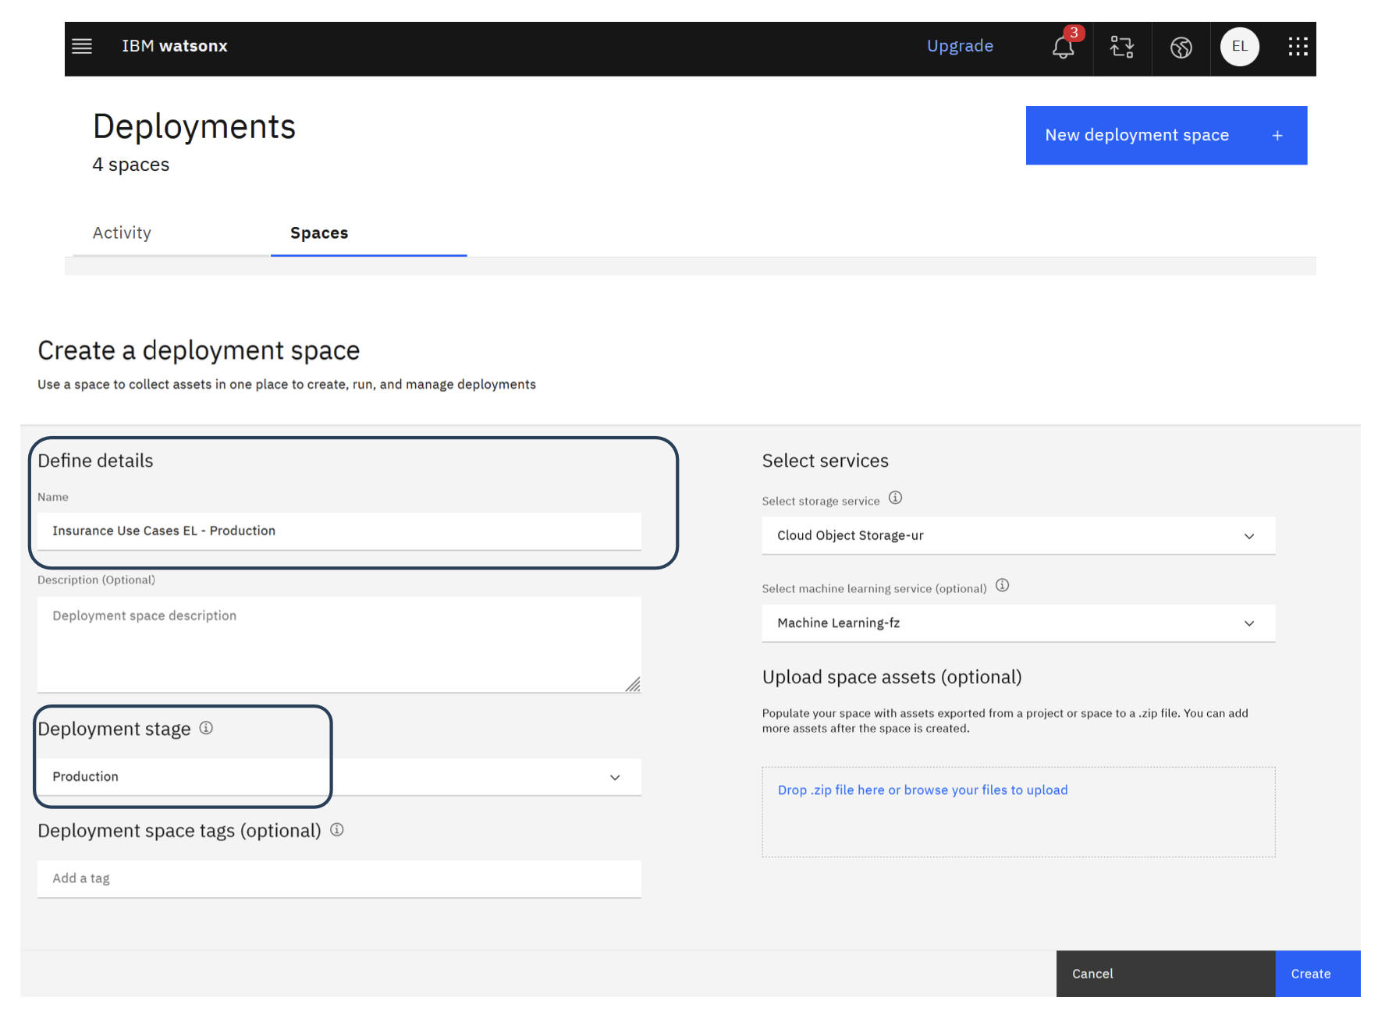
Navigate back to your projects. From the Assets view of the project, select Promote to Space.

Select the space that you previously created and click Promote.
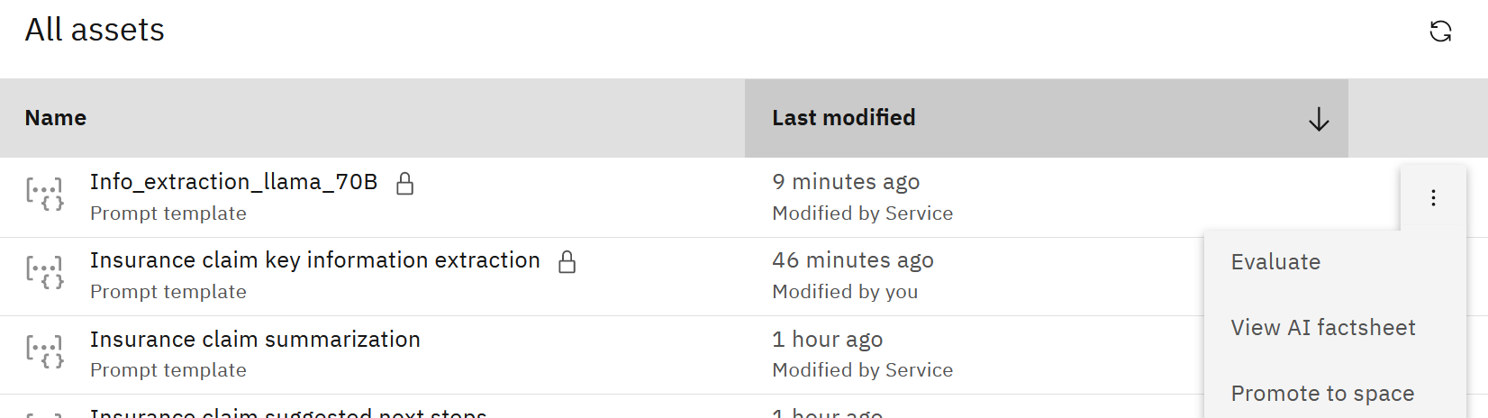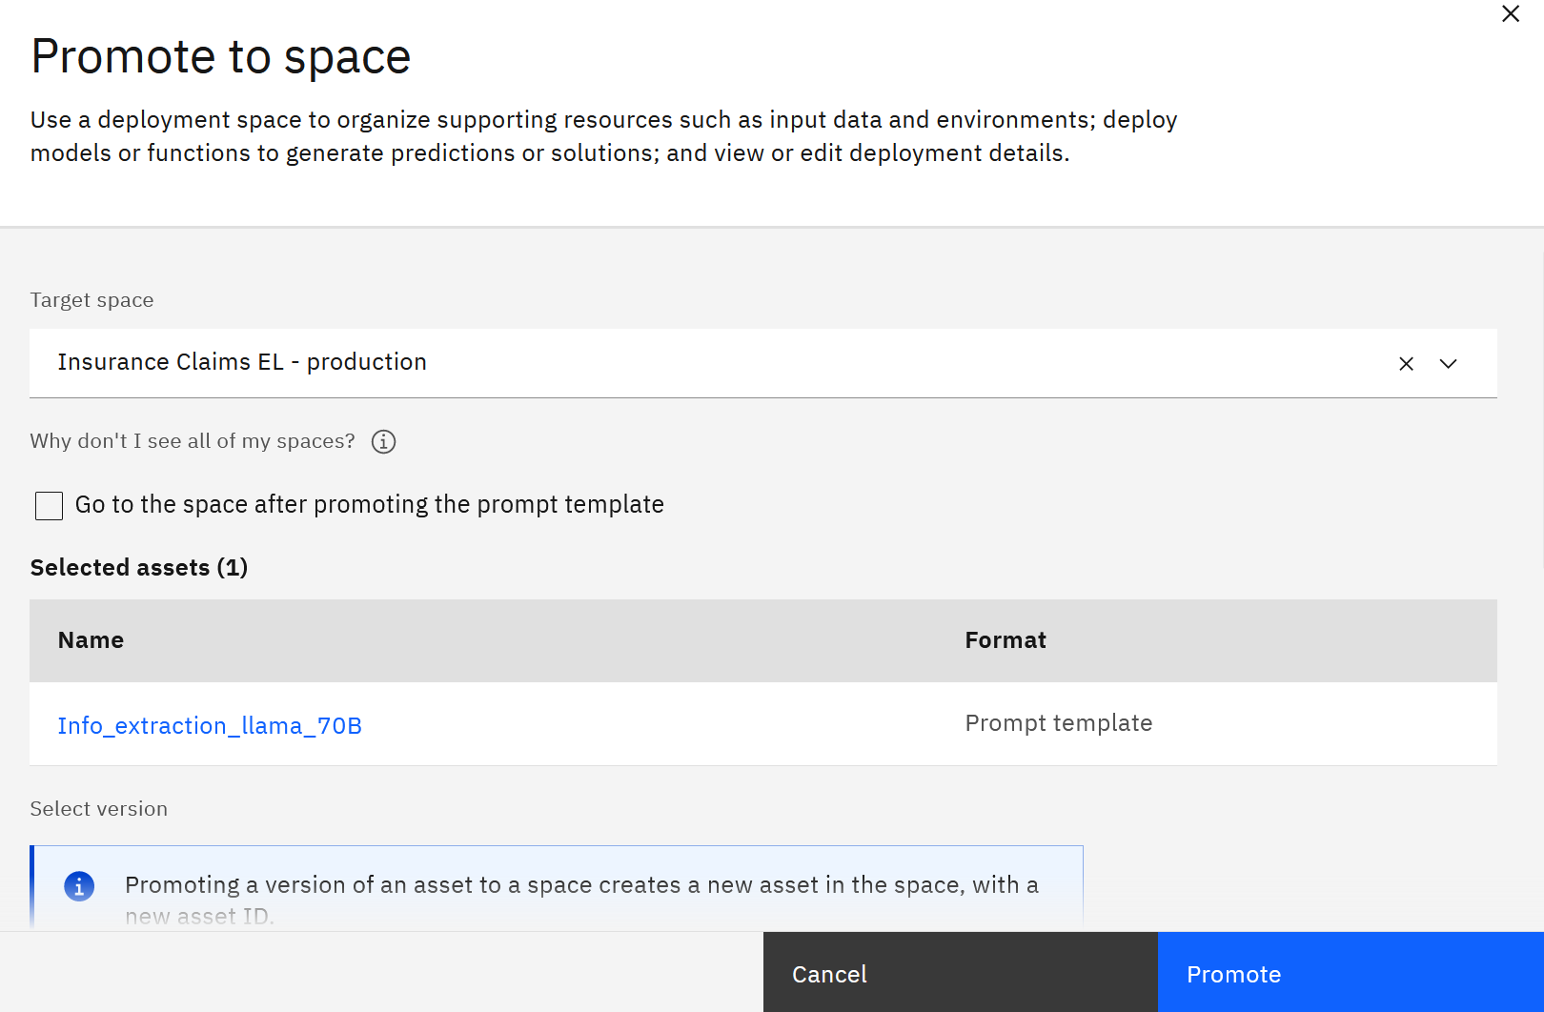
Navigate to the Deployment space. Next, we will deploy both templates. In the Assets view of the space, click on Deploy next to the template. 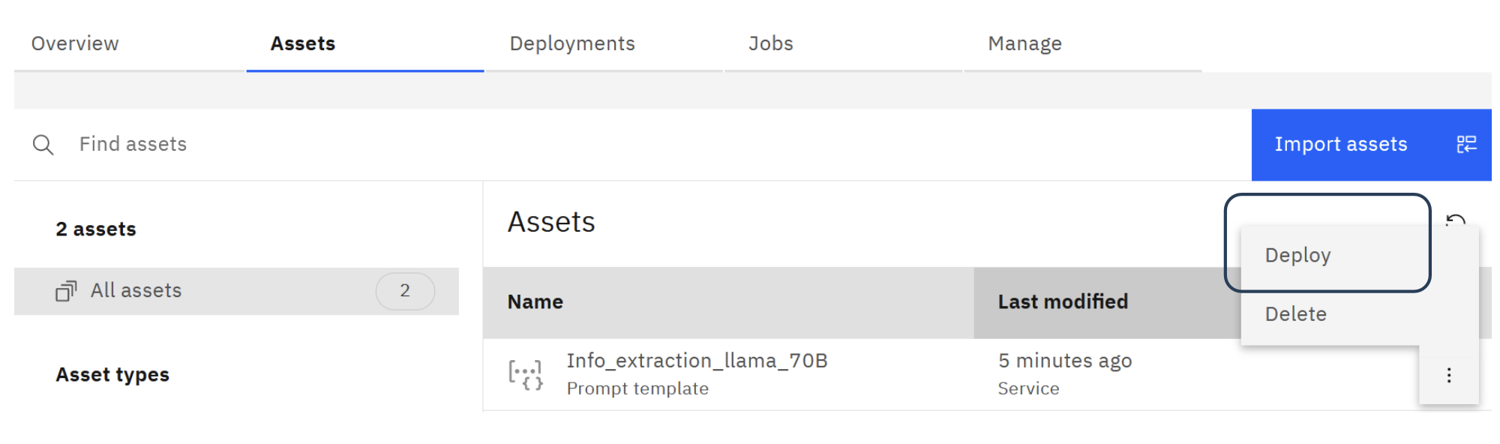

Provide a deployment name and click Create.
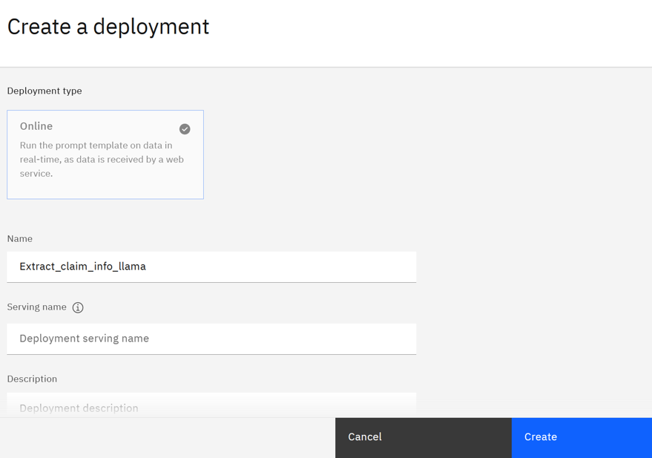
Click on the created deployment and explore the various tabs.
On the Test tab we can interactively test the prompt.
If you wish, you can copy one of the claim description values from the provided csv file
that was used for evaluations, and test the LLM.
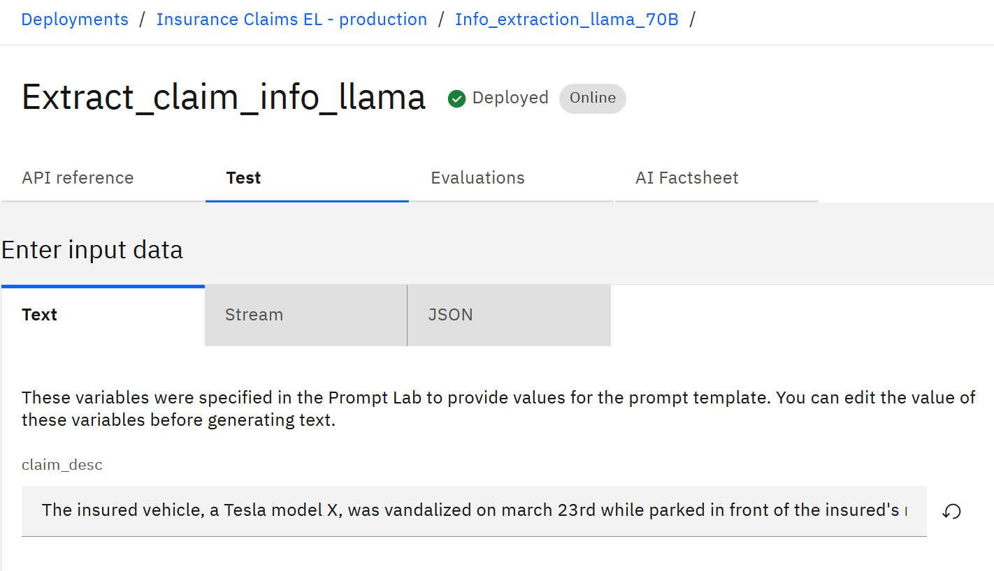
The AI Factsheet tab shows the same information as the factsheet in the project. Next we will walk through the process of setting up Evaluations.
The process of evaluation, whether it’s done manually in a project, manually in the Deployment Space, or automatically is always the same: generated output is compared with the reference data. The only difference is how generated and reference data are provided.
In production Deployment Spaces, we can set up automatic payload logging (payload data is the data that’s passed in to the LLM). You can find more information about setting up payload logging in documentation. In the development Deployment Space you setup, only manual evaluation is available via the UI.
Payload logging is not in the scope of this lab. Since we do not have payload logging configured, we can go through the setup process and run manual evaluation.

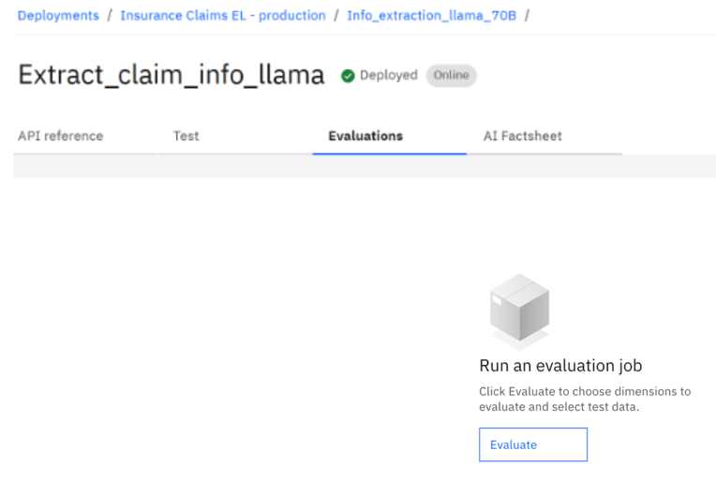
On the Evaluations tab click Evaluate.

Click on Next on the Select dimensions screen (accept defaults).

On the Select test data screen browse to the test_extraction_claims.csv file.
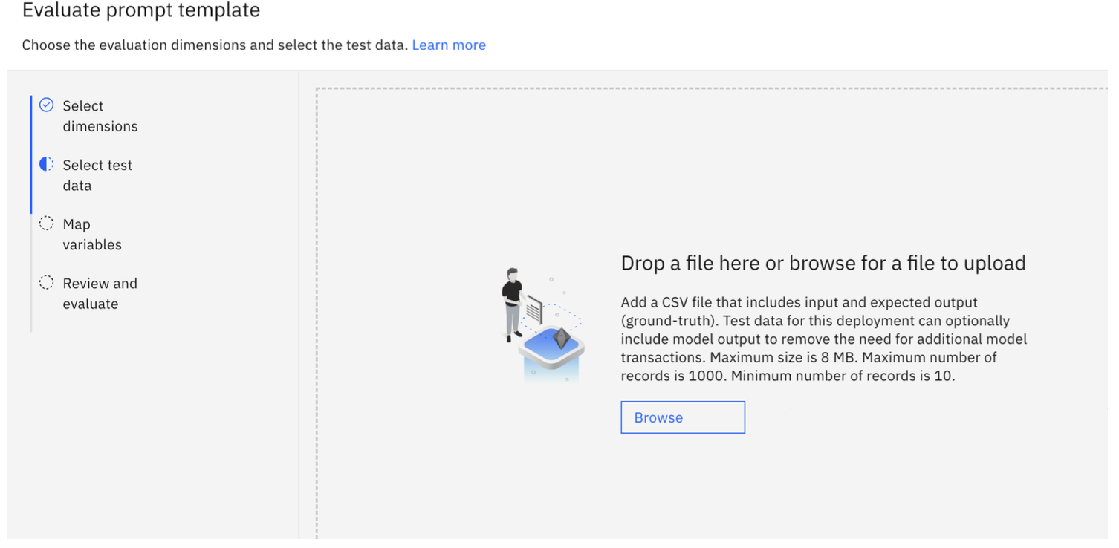Similar to the evaluation configuration in the project, select the Input and Reference output fields as showing the following screenshot.
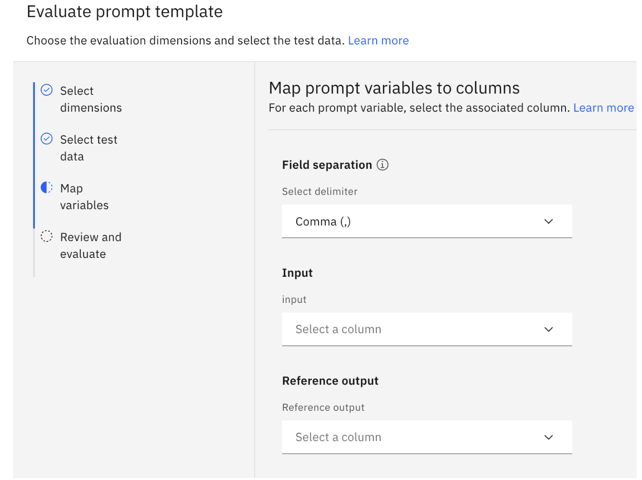
Click Next, then click Evaluate.
Review evaluation results.
*Optional Python Invoke Script for Calling Inferencing API Review

